INTRODUCING MUSICAL ARTIST
KING SWAY
King Sway releases debut album “Day Dreaming”

October 28, 2020, Farai Gwasira more commonly known by his stage name King Sway releases debut album “Day Dreaming” on label Inner Cirql Entertainment Music Group/Sway On Air, executive produced by Ethan Gwasira, Ruvarashe Gwasira, Farai Gwasira, Ifeoluwa Alaba & Munyaradzi Siyawamwaya.

An International Production featuring talents from all around the globe with Nigerian, Zimbabwean and Canadian involvement amongst others bringing together different music cultures. The vocals of every song in the album were laid in St. John’s, Newfoundland, Canada and King Sway engineered the entire project himself giving it a very personal touch.

CLICK HERE TO LISTEN & DOWNLOAD

Album Information
Artist: King Sway
Album Title: Day Dreaming
Album Genre: Hip-hop/Rap
Length: 14 Songs (40 Minutes)
Release Date: 23 October 2020
Label: Inner Cirql Ent. Music Group/Sway On Air

Tracklist
- Let’s Pray (Intro To Intro)
- Murder
- Epiphany
- Addiction (feat. Ife Alaba)
- Alright
- I, Swear
- Eazy L’s
- Tariro’s Interlude
- Reminisce (feat. Emilee Heffern)
- Heartbreak (Would’ve Been Kelly’s Interlude)
- Close (Celine’s Fave) [feat. Ife Alaba]
- Close/Distant (feat. Ife Alaba). [Extended]
- Wrong (feat. Tania)
- Day Dreaming (Outro)

Production Credits
Executive Producers: Farai Gwasira & Munyaradzi Siyawamwaya
Co-Executive Producers: Ifeoluwa Alaba, Ethan Gwasira, Ruvarashe Gwasira
Producers (Sound Engineer): Farai Gwasira, Ifeoluwa Alaba (Assistant) & Brian “KC” Amadi (Assistant)
Producers (Beat Maker): Farai Gwasira, CERTI, ENCORE, HIPPY JACK, LUVBENJI, PDUB THE PRODUCER, RICCI, SCANDI & VITALS
Recording Studio: Inner Cirql Studios
Recording Location: St. John’s, Newfoundland
Songwriters: Farai Gwasira, Ifeoluwa Alaba, Samukele Sibanda & Emilee Heffern
Graphic Design: Munyaradzi Siyawamwaya (Manik Visuals) & Farai Gwasira
INTRODUCING MUSICAL ARTIST
KING SWAY
King Sway releases debut album “Day Dreaming”

CLICK HERE TO LISTEN & DOWNLOAD

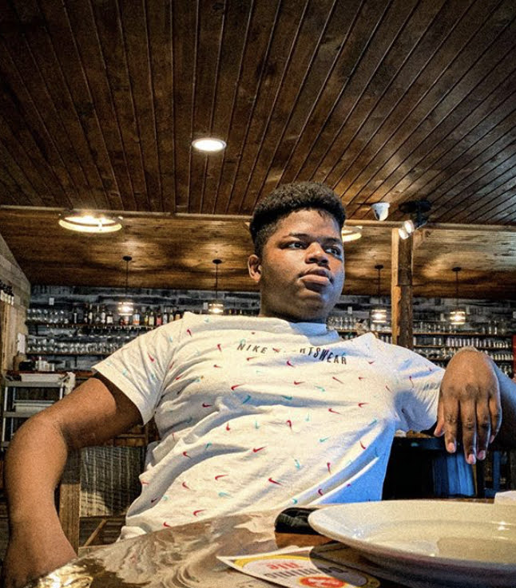
King Sway (Born Farai Gwasira on January 6, 1999) is a Zimbabwean rapper, singer, songwriter, and producer. He is the oldest of 3 children, and in his early life, Sway turned to music as a form of therapy after the untimely passing of his grandfather and role model in June 2016. King Sway’s career began when he moved to Canada with his first appearance on a single Savage Mode in January of 2018, which would be followed by 10 more singles between 2018 and 2020. He is known for his witty wordplay, curious sound, and creative style that combine stories of pain throughout his life and a sense of uneasiness with melodies that hit the heart at just the right spot. Sway's sound transcends any particular genre, known for crossing over from pop rap to trap, dancehall, R&B and Pop. He has named artists such as Drake, Lil Wayne, Big Sean, Tory Lanez and local musicians as influences on his style and music.

Contact Information
Email (Main): fvrrie@gmail.com
Email: management@swayonair.com
Phone: +1(709) 219-4197

Social Media
Instagram: @fvrrie
Twitter: @fvrrie

